**DigitalSelf Token (DSF):**

Token location and Information

**Contract Address**

[https://polygonscan.com/token/0x4EFee4288002113eD24B7d62dEf193955ED186E0?a=0xbde2b2881186a89c76667cf2970d6c112b4761c a](https://polygonscan.com/token/0x4EFee4288002113eD24B7d62dEf193955ED186E0?a=0xbde2b2881186a89c76667cf2970d6c112b4761ca)

**CERTIK AUDIT** = **Passed**

Multi Sig wallet addresses

Treasury - Reserves

<https://polygonscan.com/address/0xf7242fe299a1d1488f1025faa718054f8acb4bf4>

Treasury - LP

<https://polygonscan.com/address/0x405b617663a4816f7bda5f6e803bfd54eefa11b1>

Stakeholders

<https://polygonscan.com/address/0xce01540041fd200f9ff5a52cbfa7bbd663319ec7>

Ecosystem Partners

<https://polygonscan.com/address/0xdec248f92e74b0bb85531cbe549600055071b232>

Bounty <https://polygonscan.com/address/0x79e07DAd18B1F259de708F7a007Ab7b378965234>

Token sale

<https://polygonscan.com/address/0x7C8a0591f80B213f0b0a011214448091ca1aF61E>

This graph shows the distribution of the token currently and any address that is surrounded by a green box corresponds to one of the DS addresses above

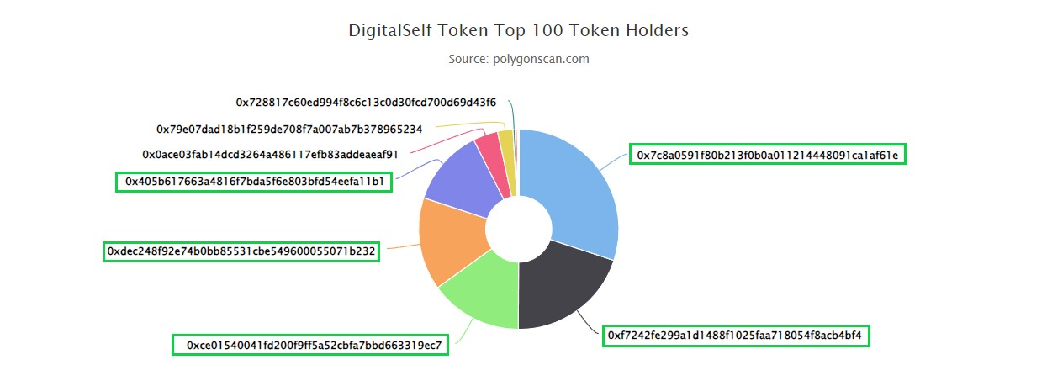

.This graph is public and can be found at

<https://polygonscan.com/token/tokenholderchart/0x4EFee4288002113eD24B7d62dEf193955ED186E0>

The Breakdown of the graph that has the most Holdings is as follows

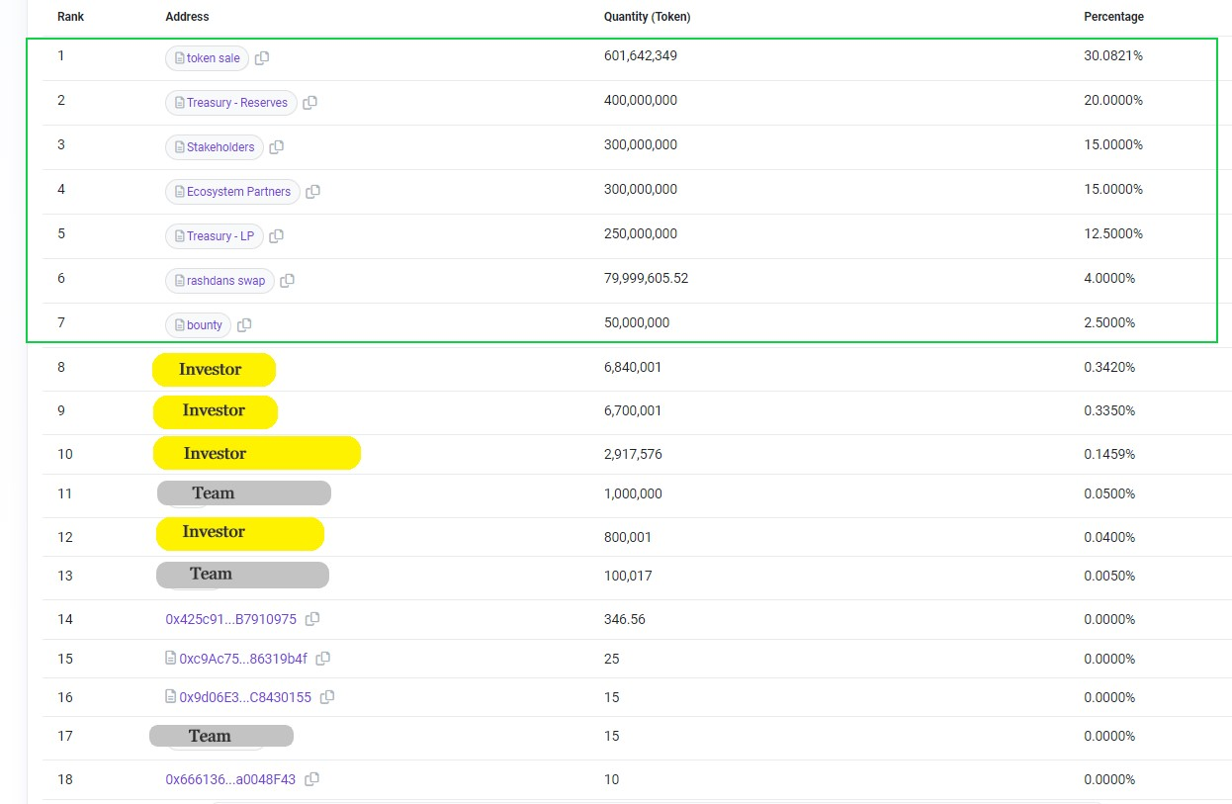

As you can see from the graph above there is a green box which contains all the digital self multi-sig wallets which are all in the control of DigitalSelf.

Anything that is in yellow /investor I have placed there to cover the investors name as they are entitled to their privacy.

Once agreements have been made with exchanges then time lock safes and vesting contracts will be implemented as per white paper.

I have provided pictures of each DigitalSelf wallet for your convenience to show that the amount that has been declared in the white paper which corresponds to the wallets.

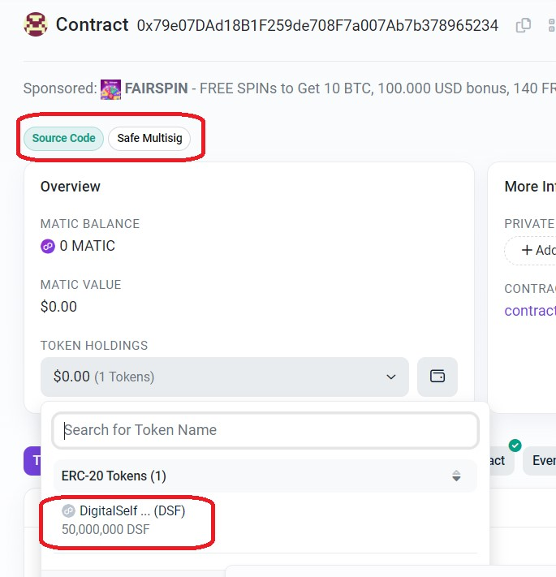

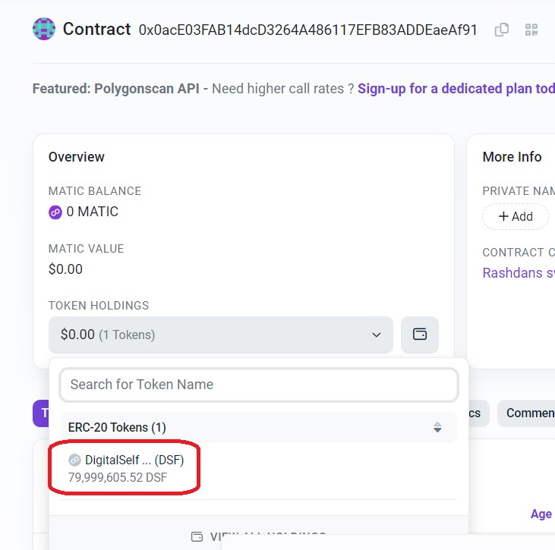

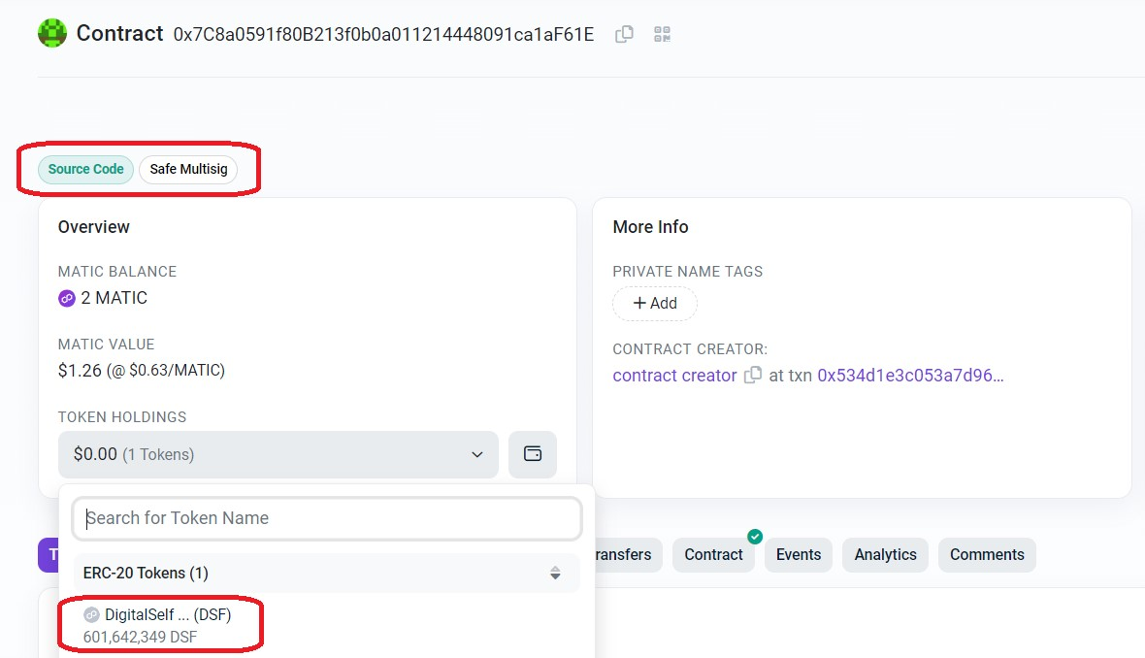

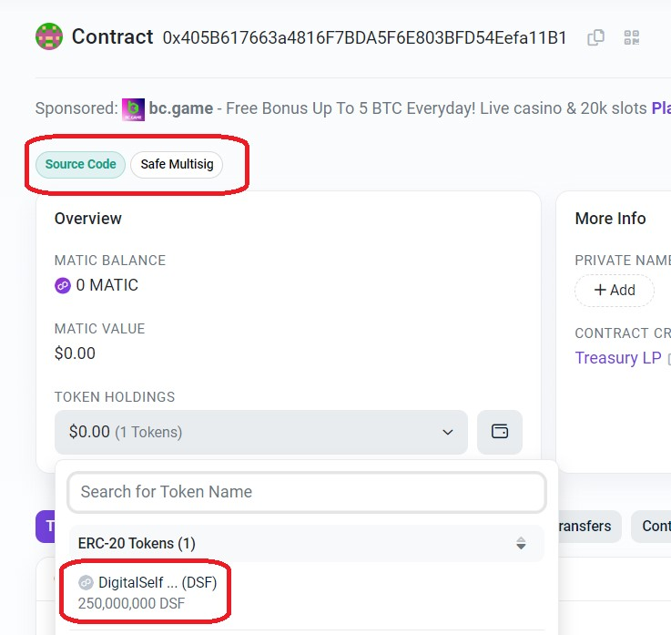

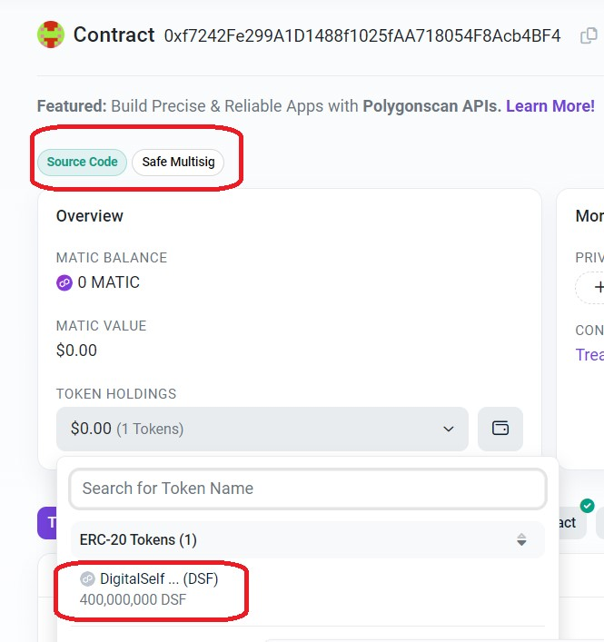

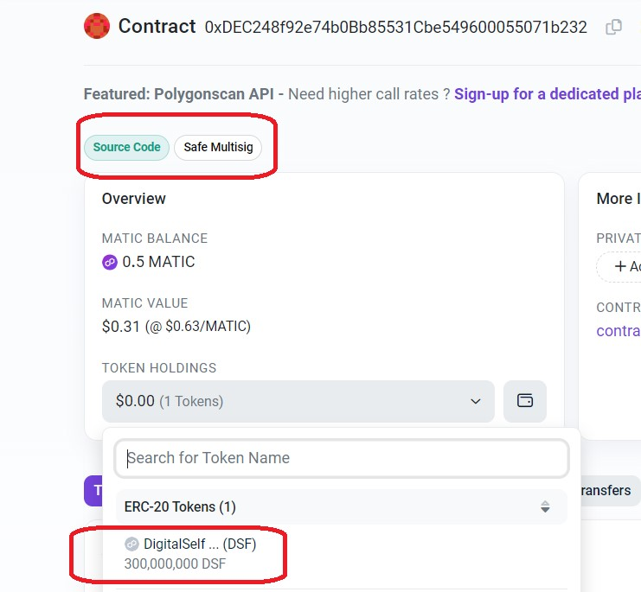

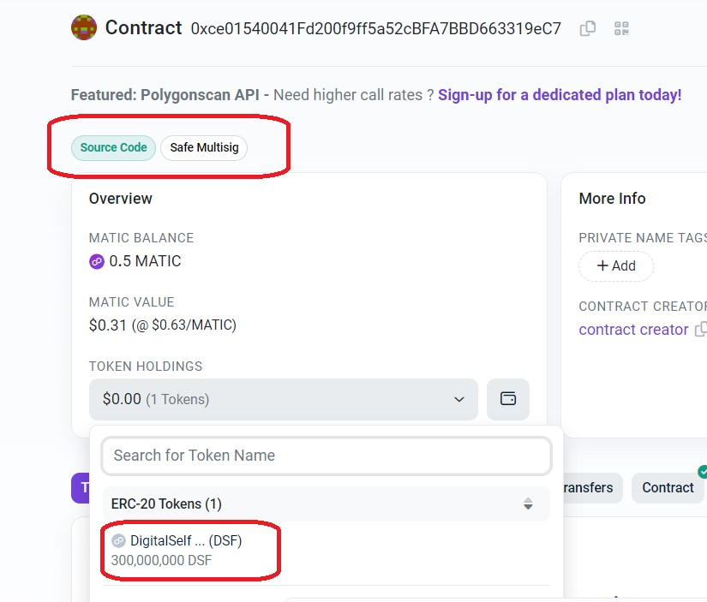

As you can see from the above photographs, I have circled in red the amount of DSF tokens in that address and on the top I have circled the area where it shows you that is is a safe multi-sig wallet.